273 emulator creation and system variables

Commands to run but more set up is needed

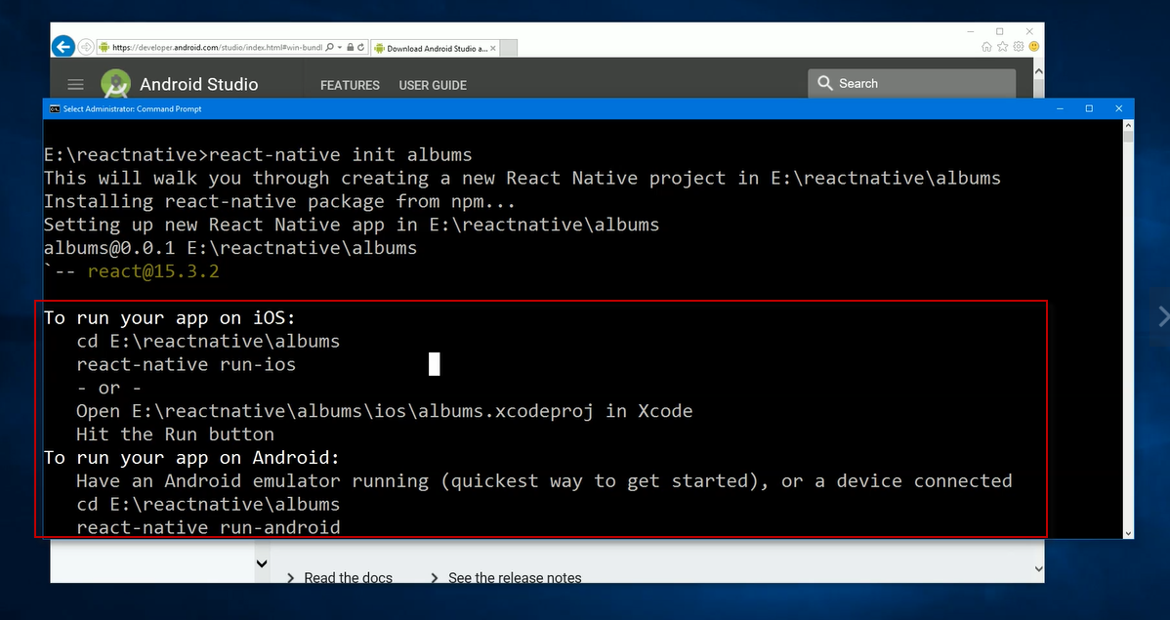

Open android studio – then the project

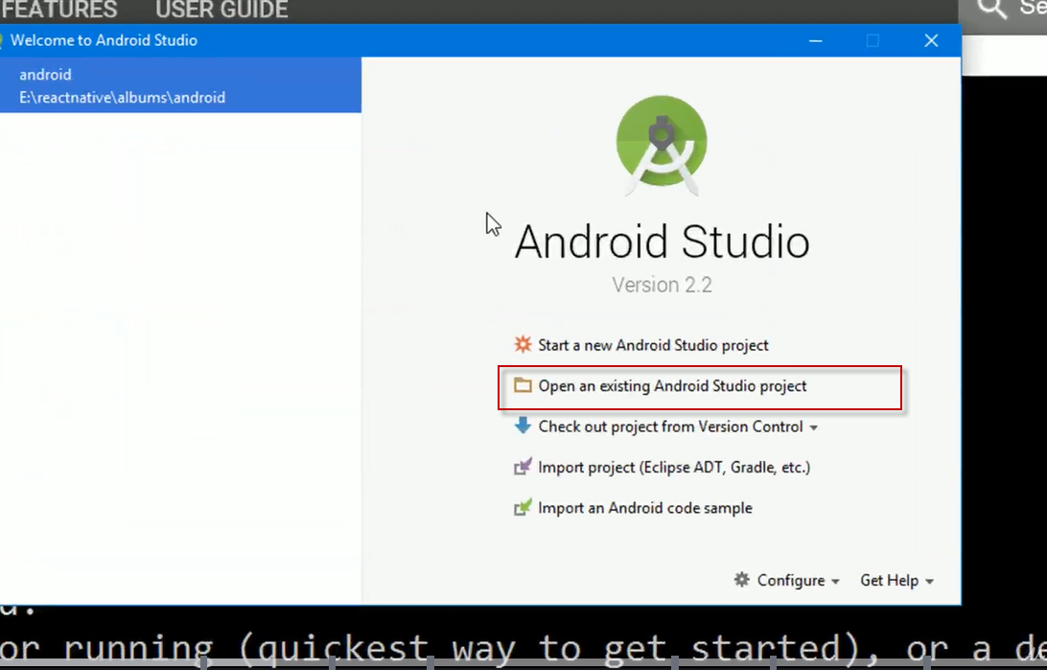

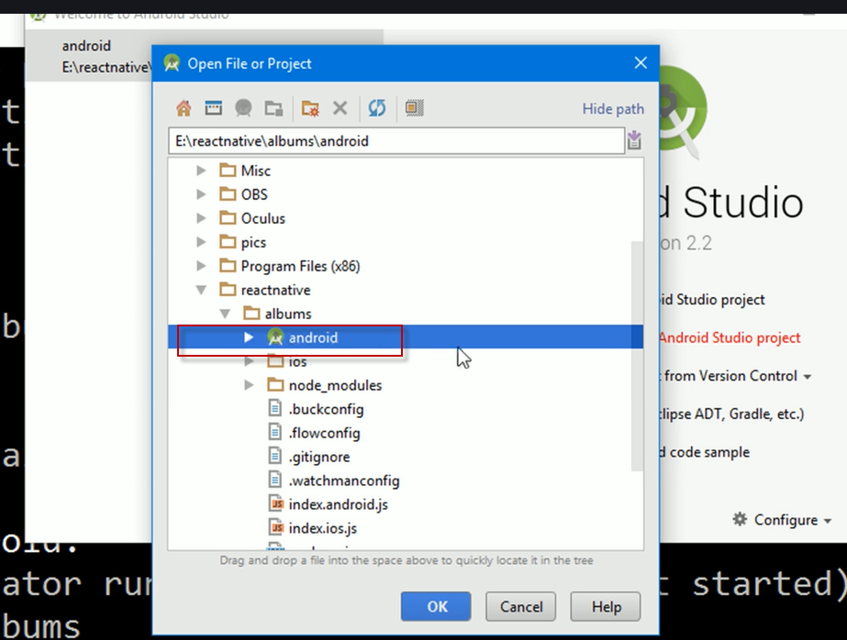

When first opening get an error message but may need to wait a couple to see it

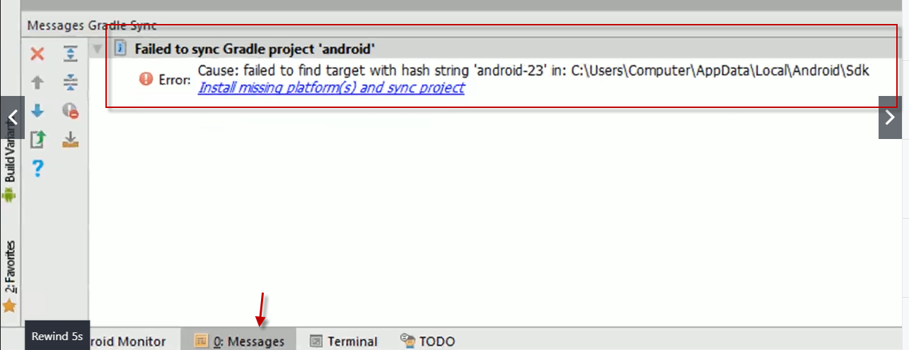

Use the blue hyperlink to fix this .

Download and install this bit of software – SDK Quick Fix

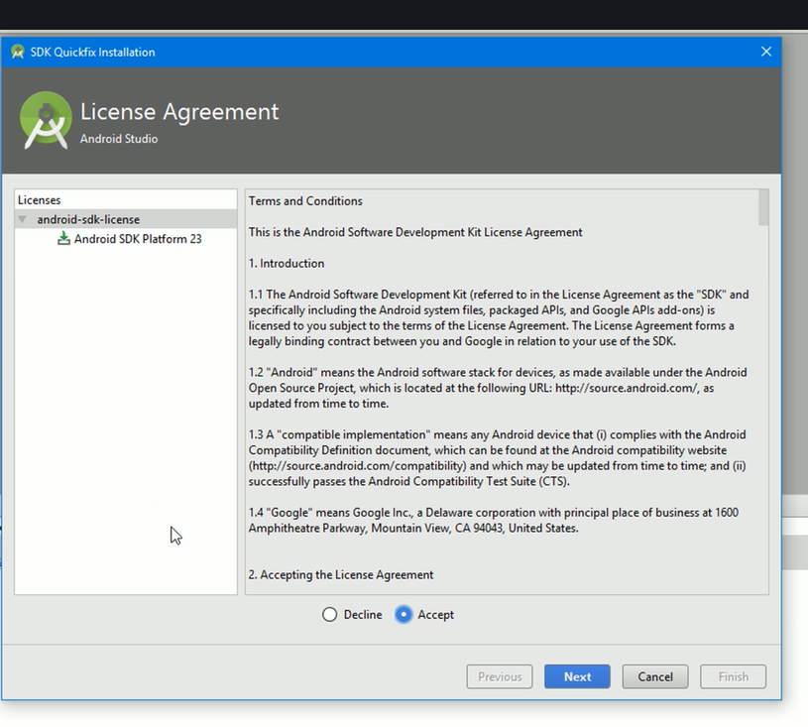DL and install

When that is done there will be another error and thing to install

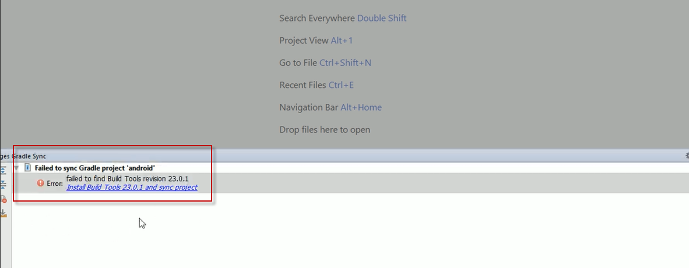

Click on this link and install

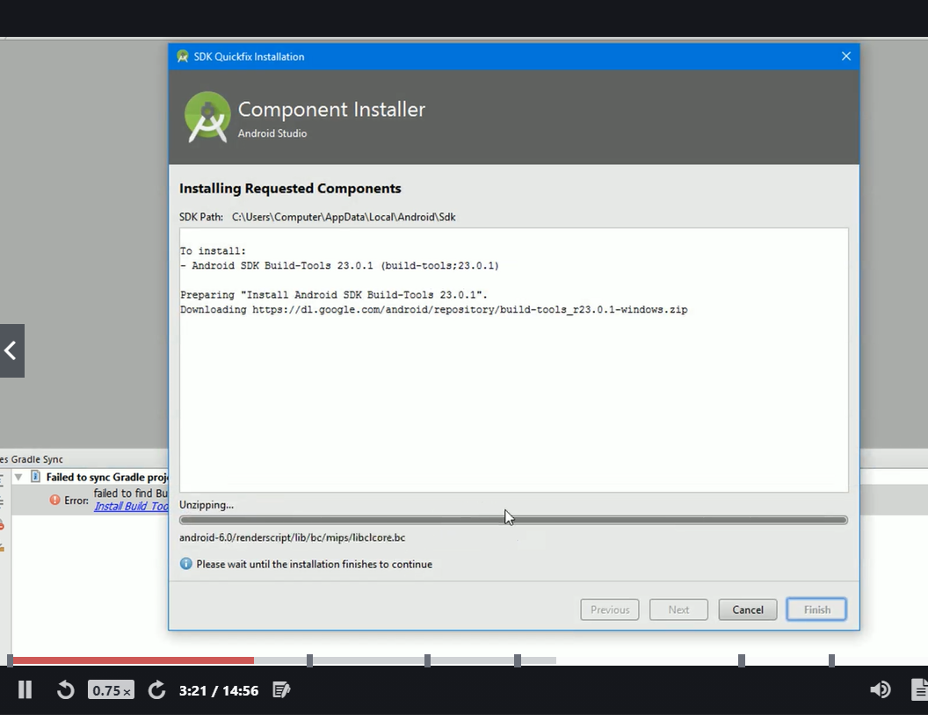

If you get this click don’t remind me again

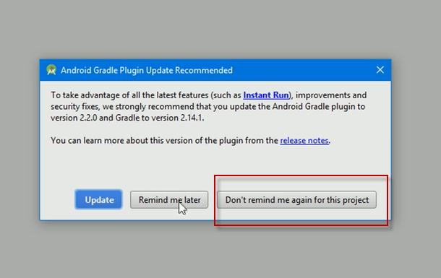

Now set up android emulator

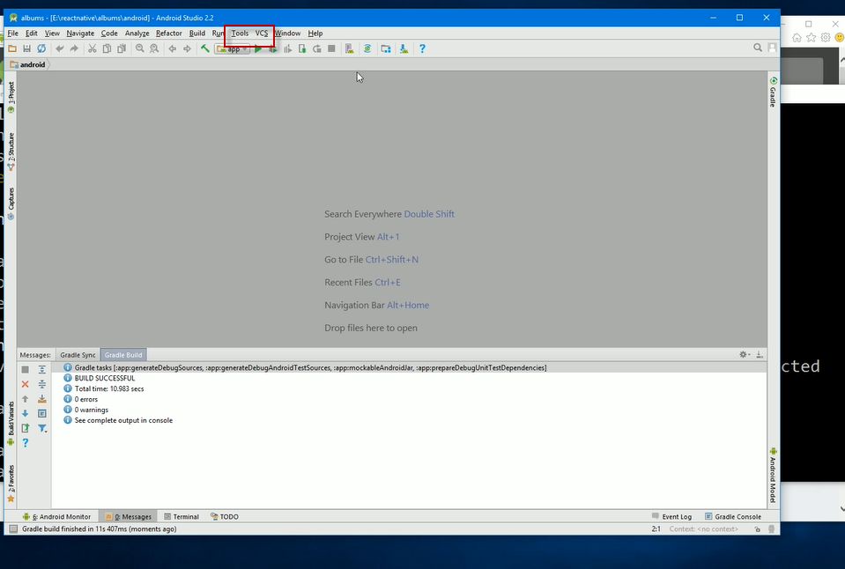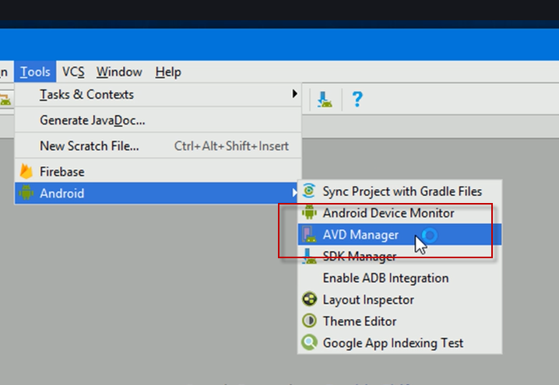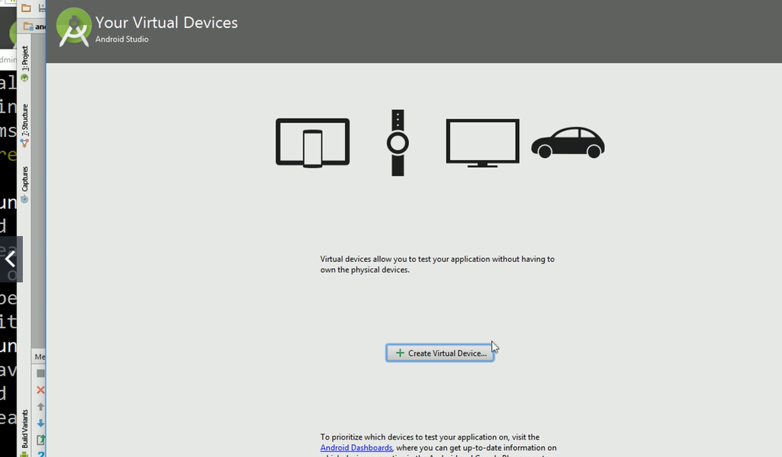

This allows running android os inside windows

Pick a device with screen size @ 5 inches

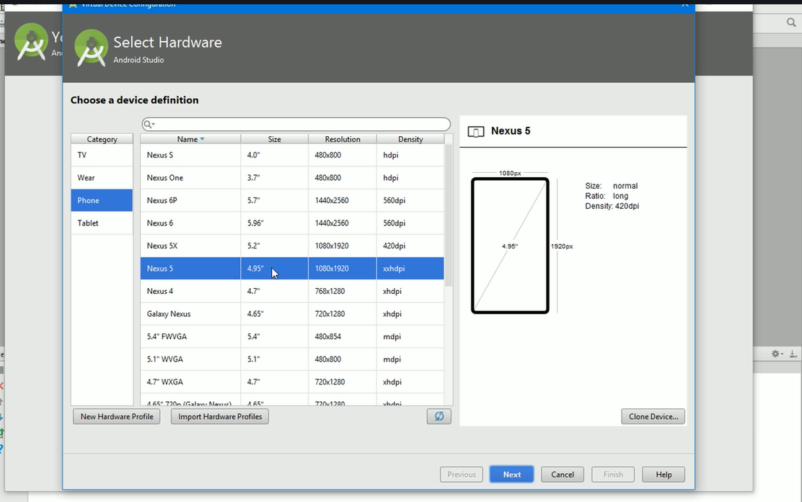

Need version 23 for react native

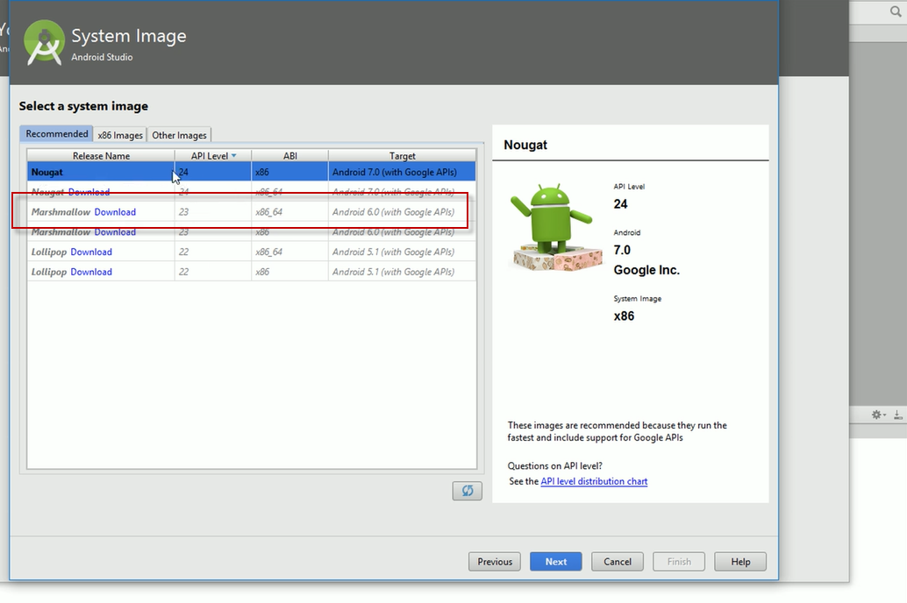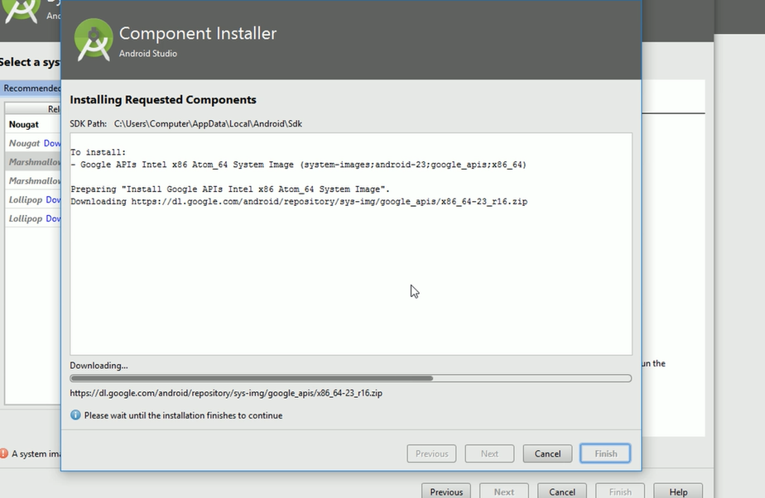

After DL select it

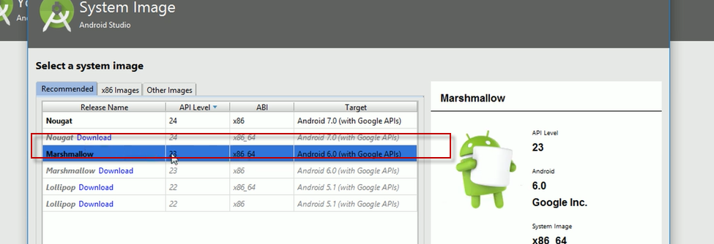

Info about device – just click finish

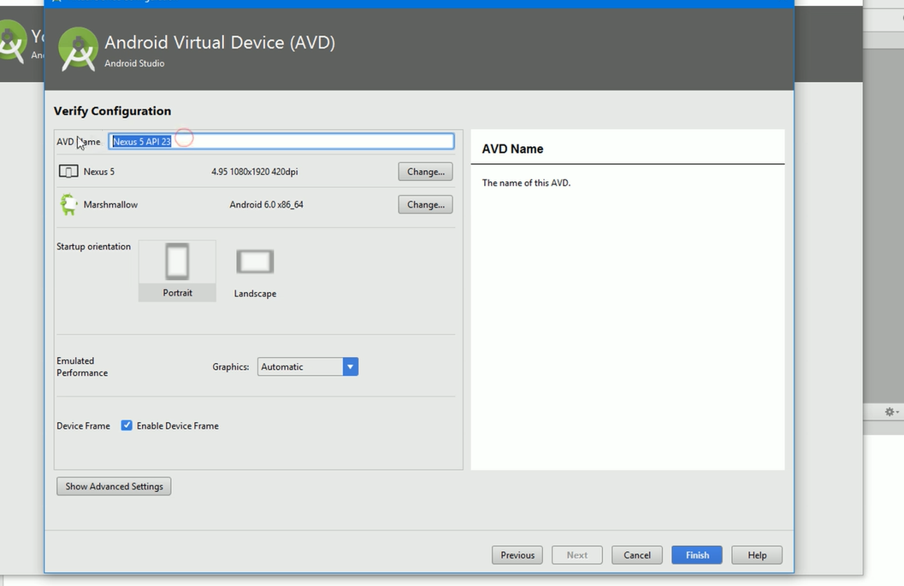

Now pick device – this is the emulator

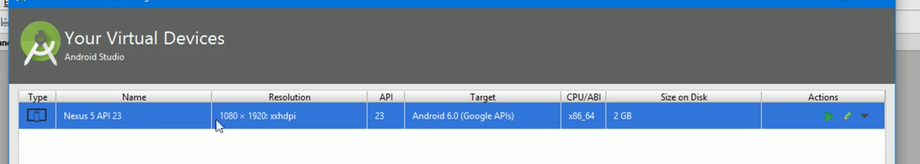

Click play button to start emulator

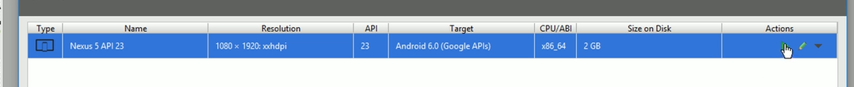

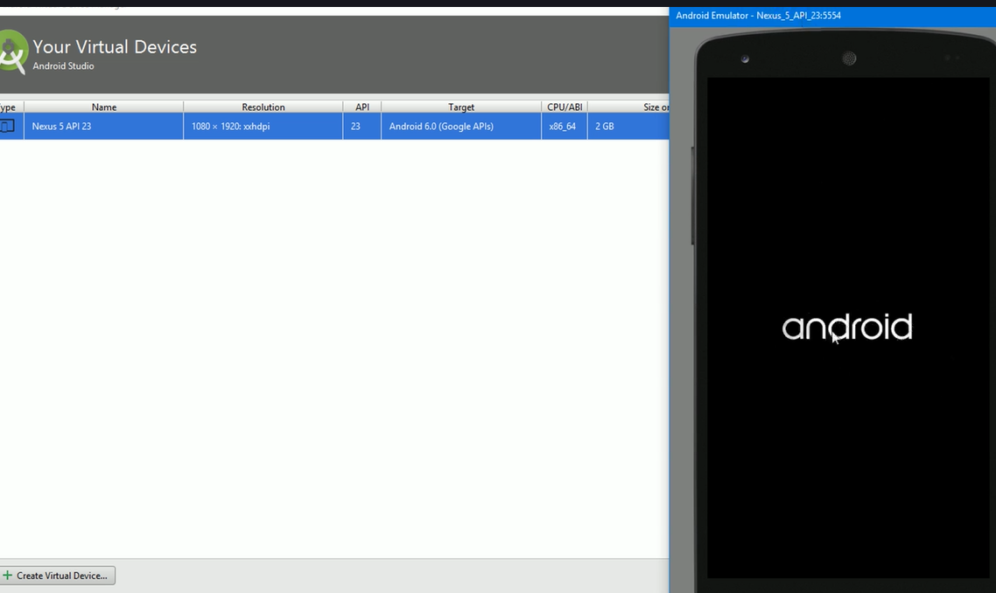

Now go to system settings

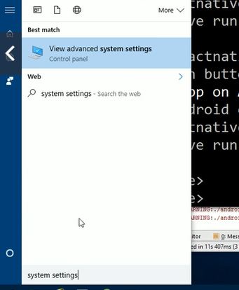

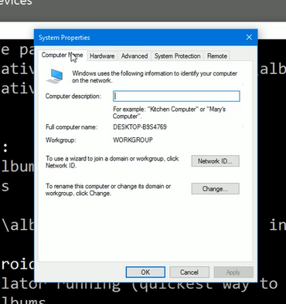

Advanced and environment variables

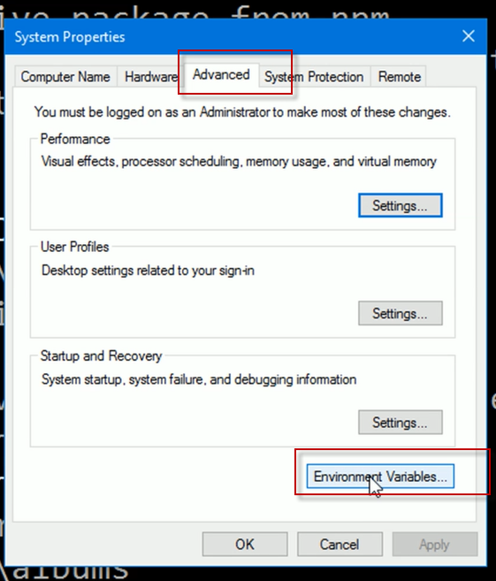

Will be adding 2 env vars

Click on new

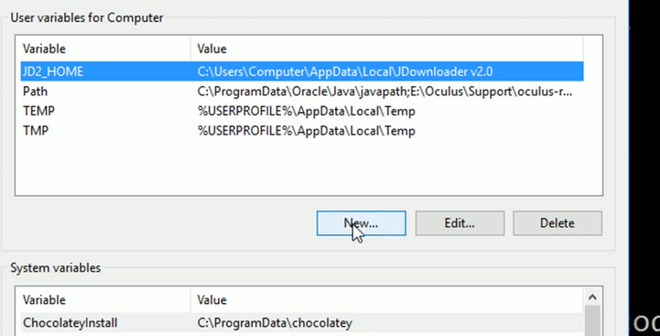

Enter name of JAVA_HOME – if you already have this do not have to add it.

The react native packager expects to have access to JAVA_HOME 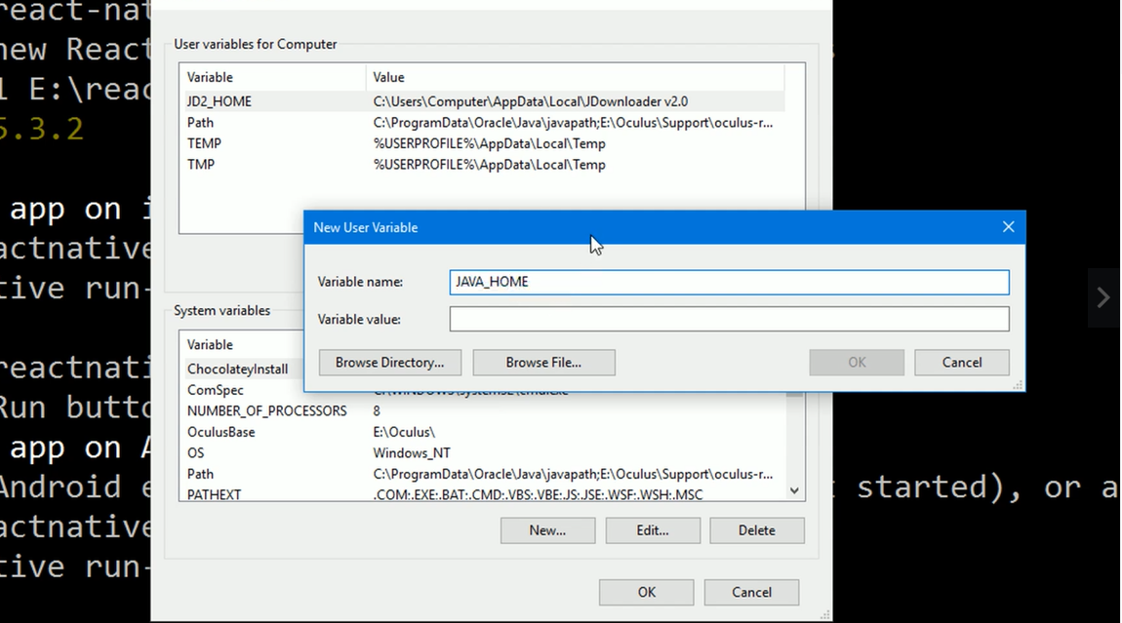

The variable value – browse dir, this PC , C drive , java and jdk we just installed

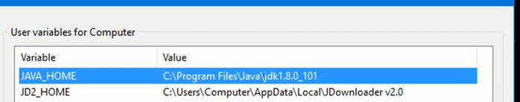

Now need to add another directory to path variable .



Select click edit then new

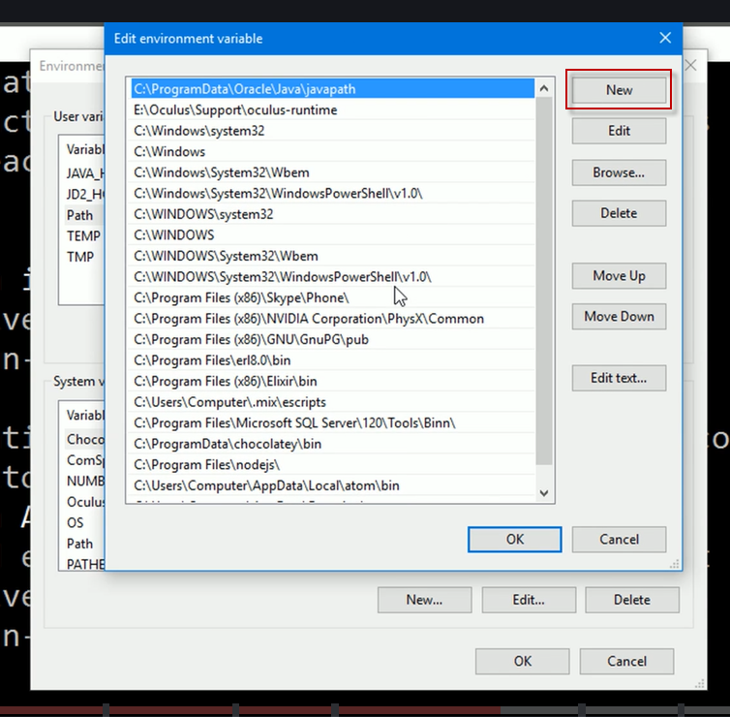

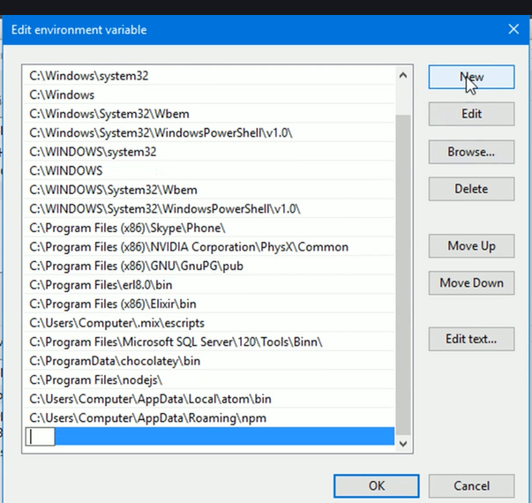

Find the location noted earlier , computer name and enter the path replacing computer with login user name

Point to app data , local , android , sdk , platform tools

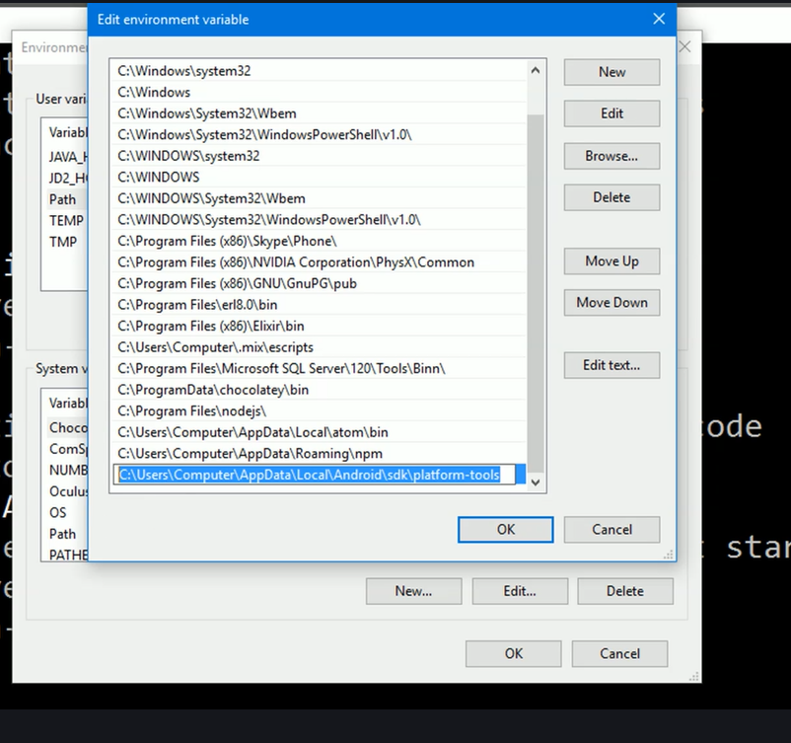

Can copy paste this in windows explorer to verify that it exists.

When done ok ok ect out the restart command prompt – close it then

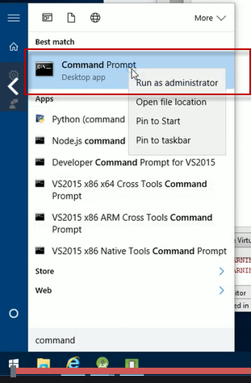

Then cd back to the project and run-android

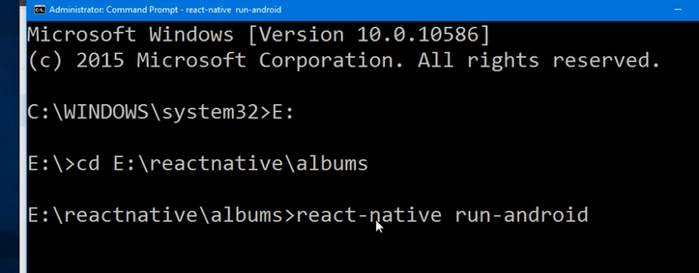

Press cntl-N to open development menu

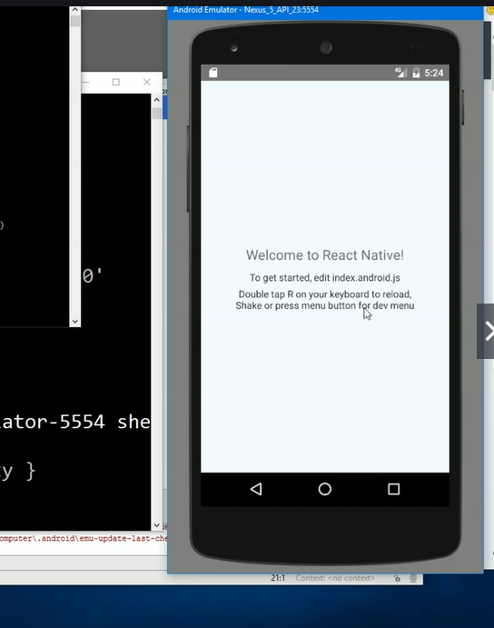

To restart when coming back to a project open up studio , tools , android, AVD manager and play button

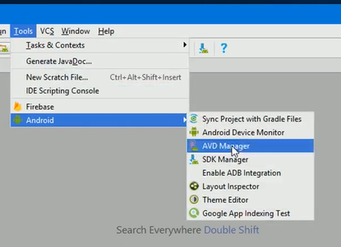

Then in command prompt run

